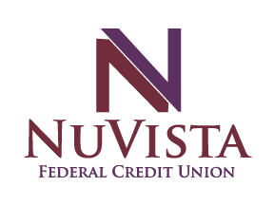
Utility Assistance Request

Member Number: ______________________

Name: ________________________________

Phone Number: ________________________

How have you been negatively impacted by Covid-19?
- Loss of Job
- Cut Hours
- Other:____________________________________________

Instructions:
Must submit with copies of utility bills - Restrictions Apply
*Must be a current NuVista FCU member
*Utility bills must match name and address on our records

Requests can be submitted via:
Night drop at both our Gunnison & Montrose branches
Drive up at the Montrose branch during business hours
Emailed to utilityassistance@nuvista.org

If you have any questions, please call us at 970-249-8813

