***Sponsorship/Donation Request Form*** 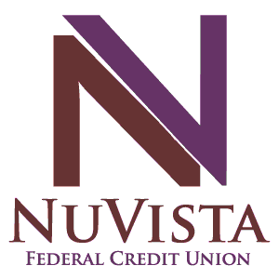

Thank you for coming to NuVista Federal Credit Union with your request. NuVista is a community based not for profit financial institution serving our Members in Montrose, Gunnison, Ouray, and San Miguel counties. We ask that all Sponsorship/Donation requests are submitted 30 days prior to the Sponsorship/Donation deadline.   
  
***General Information***  ***Contact Information***

Date: __________________________________________ Name: __________________________________________  
Organization: ___________________________________ Phone: _________________________________________  
Address: _______________________________________ Email: _________________________________________  
Phone: ________________________________________ Check Written to: ________________________________  
Website: _______________________________________   
Name of Event: __________________________________   
Date of Event: ___________________________________  
Location: ______________________________________ Purpose of Event: ________________________________ _______________________________________________   
_______________________________________________   
Sponsorship/Donation Amount Requested: _______________________________________________

***Partnership Benefits***If any, please list all sponsorship benefits, included but not limited to: Banners, Program Recognition, Advertisement, etc.  
__________________________________________________________________________________________  
_____________________________________________  
***Sponsorship Benefits Available:***   
 Banner Placement at Event   
 Event Product Literature Distribution How Many? _____  
***Places of Distribution of Logo:*** Advertisements  Registration Forms   
 T-Shirts  Flyers   
 Poster  Link on Website  
 Radio Recognition  Social Media/Other  
 If Other, Please Describe: _________________________  
__________________________________________________  
__________________________________________________

Is your Organization a Non-Profit? Yes No

Proceeds go to Charity? Yes No   
If Yes, which Charity? _______________________________________________

Is this Organization/Non-Profit a Member of NuVista Federal Credit Union? Yes No   
  
Is the Coordinator a Member of NuVista Federal   
Credit Union? Yes No

By completing this form, you fully understand that this is not an agreement, but only a Sponsorship/Donation request.   
  
Print Name: _______________________________________ Signature:_______________________________________

Please submit completed Request Form via mail or email:   
NuVista Federal Credit Union  
Attn: Donations Committee  
PO Box 1085, Montrose, CO. 81402  
Email: [donationrequests@nuvista.org](mailto:donationrequests@nuvista.org?subject=Sponsorship/Donation%20Request) or Call 888.261.7488 with any questions   
  
***For Office Use***

Date Received: ______________________ Donation/Sponsorship Amount Approved: ________________  
Approved By: _______________________ Date Approved: _________________  
Notes: ____________________________________________________________________________________________